Temporary Closure of Aquatic Facilities

When must you temporarily close your pool/spa?
- The emergency phone on site is absent, missing, or not functioning;
- The water chemistry of the aquatic facility is outside of required legal limits or is hazardous
to public health and safety;
  - This refers especially to levels of free chlorine, pH, and cyanuric acid/stabilizer.

Life saving equipment or signage is damaged or missing;
- The safety vacuum release system (SVRS)(if required) is not working;

Drain or suction outlet covers become damaged or detached;
- The bottom of the aquatic facility cannot be clearly seen at any part of the water body;
- The aquatic facility equipment ceases to circulate;
- The facility enclosure is damaged;
- The gates or doors to the aquatic facility enclosure fail to self-close and self-latch;
- An entanglement or entrapment hazard exists, regardless of the age of the facility; OR

Any other event exists that is hazardous to the health and safety of swimmers or of the general public
  - Here are a few examples of other hazards that would require closure:
    - Potential electrical hazards;
    - Potential falling hazards (i.e. unsafe trees near the water);
    - Chemical spills in or near the facility enclosure;
    - After adding chemicals to the water/during hyperchlorination/etc.; or
    - After fecal contamination.

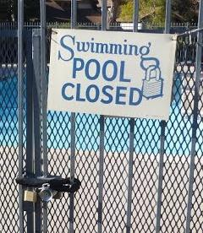
During a temporary closure, you must:
- Secure and lock all entrances into the aquatic facility enclosure. This includes entrances because of a damaged enclosure—temporary fencing must meet all enclosure requirements.
- Post a sign on all entrances reading “Pool Closed” in minimum 2” letters.
- If the Environmental Health inspector closes the facility, you must not remove the sign that the inspector puts in place. You must also call for reinspection (903‐535-0037) and get approval from the Environmental Health inspector before reopening.

