Each pool needs to have this document kept on property and it should remain with this pool as management or ownership changes.

Purpose of the Manual: Below is a template tailored to facilities in Texas, incorporating guidelines from the 2021 International Swimming Pool and Spa Code (ISPSC), Texas Administrative Code (TAC) 265, and best practices from the Model Aquatic Health Code (MAHC).

1. Facility Overview:
- Pool Detail
  - Detail. (volume, depths, surface area, designed turnover rate, shape, etc)
  - Dates. Year built and dates and description for any remodels thereafter
  - Designed Bather Load.
  - Pool classification & primary uses
    - Examples: (class A,B, or C etc) and primary use: resident and guests only, swim lessons, general public, etc.
- Schematic Diagrams. Provide diagrams of the circulation system, markings for directional flow, clearly labeling valves, pumps, filters, and chemical feeders.

2. Equipment and Manuals
- Inventory List: Detail all equipment (pumps, filters, heaters, skimmers, main drains, gauges, meters, chemical feeders, etc) with model numbers and specifications.
- Operating Manuals: For each piece of equipment on the inventory list, include documentation for date of installation & include manufacturer operation manuals
- Maintenance Manuals: For each piece of equipment on the inventory list, the maintenance manual needs to be available for observation
- Records. Records need to be kept for maintenance and repairs for equipment.

3. Water Quality Maintenance Procedures
- Chemical Balance:
  - Source Water. Well Water is to have Coliform testing performed monthly
  - Stabilizer. When cyanuric acid is used, testing needs to be performed at least once a week
  - Water Balance.
    - Langelier Saturation Index Test water balance at least every 10 days
    - Alkalinity Test at least every 10 days
    - Calcium hardness. Test at least every 10 days
  - Disinfectant Levels & pH
    - Class A & B.
      - Manual Tests required every 2 hours; or
      - Automatically controlled. Tests required 3 times a day
    - Class C & other class pools with onsite staff
      - Manual Tests required 3 times a day
      - Automatically controlled. Tests required 1 time a day
    - Class C with satellite staff such as an HOA
      - Manual Test 1 time a day
      - Automatically controlled. Tests required 1 time a day and 1 time a week manually
- Secondary Disinfection System. Maintained onsite
  - Validation records (as applicable)
  - Operation records
- Records.
  - Log Sheets: Log sheets must be completed daily, easily accessible and retained for 3 years for review
    - If multiple pools/spas onsite, Identification of the pool tested required
    - Date and time testing performed
    - Chemical Level
    - (automated controller reading) if applicable
    - mV of ORP meter where applicable; and
    - Corrective Actions: Documentation Steps taken to adjust chemical levels when tests fall outside acceptable ranges.
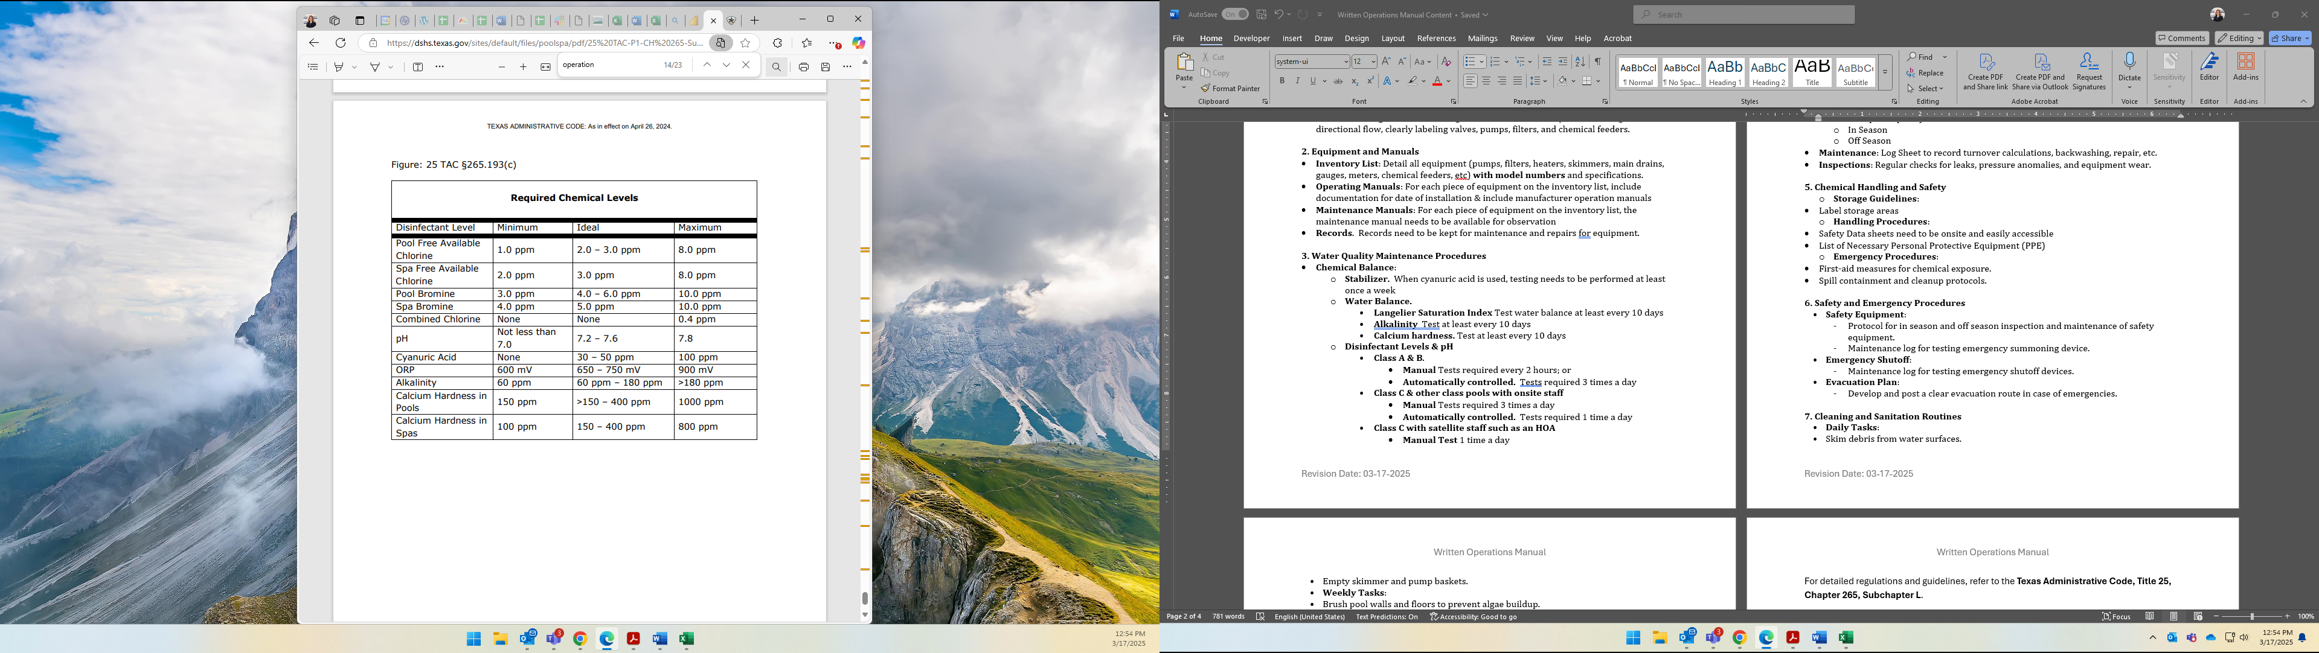
4. Filtration and Circulation Protocols
- Turnover Rates: Ensure complete water turnover as specified by pool type (e.g., every 6 hours for public pools).
- In Season
- Off Season
- Maintenance: Log Sheet to record turnover calculations, backwashing, repair, etc.
- Inspections: Regular checks for leaks, pressure anomalies, and equipment wear.

5. Chemical Handling and Safety
  - Storage Guidelines:
- Label storage areas
  - Handling Procedures:
- Safety Data sheets need to be onsite and easily accessible
- List of Necessary Personal Protective Equipment (PPE)
  - Emergency Procedures:
- First-aid measures for chemical exposure.
- Spill containment and cleanup protocols.

6. Safety and Emergency Procedures
- Safety Equipment:
  - Protocol for in season and off season inspection and maintenance of safety equipment.
  - Maintenance log for testing emergency summoning device.
- Emergency Action Plan
  - Emergency Contact List
    - Phone numbers of contacts for Property, emergency and health department
    - Certified Pool Operator. Name, certificate, NET Health Registration, phone number
  - Location of First Aid Kit or other emergency equipment (AED,Backboard, etc)
  - Inclement Weather Response Plan (thunderstorm, lightening, high wind, flood, etc) including evacuation areas
- Emergency Shutoff:
  - Maintenance log for testing emergency shutoff devices.

7. Cleaning and Sanitation Routines
- Daily Tasks:
- Weekly Tasks:
- Monthly Tasks:
- Seasonal Tasks:

8. Recordkeeping
- Logs:
  - Maintain daily records of water chemistry readings.
  - Document maintenance activities and equipment inspections.
- Compliance:
  - Ensure records are accessible, retained at least 3yrs and remain with property

9. Winterization and Seasonal Maintenance
- Closing Procedures:
- Opening Procedures:
- Inspect and clean all equipment before restarting.
- Maintenance and Balance water chemistry.

10. Staff Training and Responsibilities
- Certifications:
  - Ensure staff have required certifications
  - Certified Pool Operator (CPO)
    - Registered with NET Health
    - Contact Information Needs to be easily accessible on property
  - Basic Pool Operator Certificates. Valid Certificates of onsite personnel trained to care for the pool
- Training:
  - Provide regular training on
    - Safety Protocols
    - Emergency Response & Notifications
    - Equipment Operation and Maintenance
    - Chemical Testing, Storage and Personal Protection
    - Opening duties, closing duties

This template serves as a foundational guide. It’s crucial to customize each section to reflect the specific features and requirements of your facility. Regular updates to the manual are recommended to incorporate changes in regulations, technology, and best practices.

For detailed regulations and guidelines, refer to the Texas Administrative Code, Title 25, Chapter 265, Subchapter L.
For public health reasons refer to Annex 3 of Model Aquatic Health Code

